



**CSU Sacramento**

**Department of Electrical Engineering**

**Lab 2 Calculation of Internal Resistance of Voltmeter, Ammeter and Scope**

**Sam Lee**

**Partners: Jordan Moore, Jeffrey Hawthorn, Awfa Al-Rakabi**

**EEE 117L Network Analysis Laboratory**

**February 4th, 2019**

**Professor Sergio Aguilar Rudametkin**

**Section: 01**

**Day: Monday**

**Time: 5pm-7:40pm**

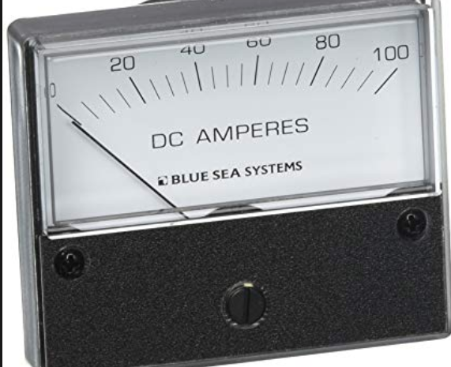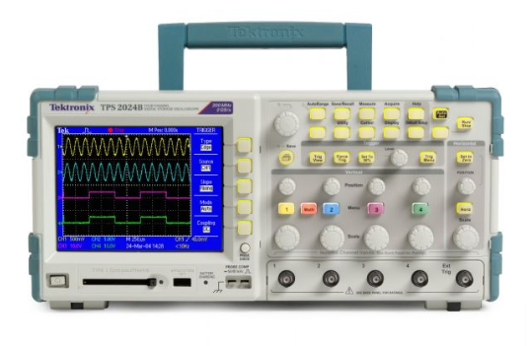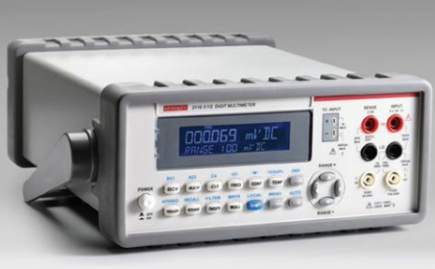

**Part 1 Introduction:**

The digital multimeter (DMM) is an essential tool when measuring circuit elements such as resistance, current, and voltage. The DMM can be a voltmeter, ammeter, and ohmmeter when set properly. The oscilloscope on the other hand measures the voltage through time therefore providing us wave forms if were working with AC circuits. In this lab the DMM and oscilloscope will be the focus of this lab as there very useful tools for future labs. However, the DMM and oscilloscope pose a problem when measuring circuit elements. Since the DMM and Oscilloscope have internal resistances they will affect any circuit measurements. In this lab my team and I will calculate for the internal resistance of the voltmeter, ammeter and the x1, x10, oscilloscope. The team will design and create a circuit to model a voltmeter, ammeter, and oscilloscope and later solve for the internal resistances by using methods such as Kirchhoff’s voltage law, Kirchhoff’s current law, voltage division and current division.

**Part 2 Purpose:**

The purpose of this lab is to calculate the internal resistance of the voltmeter, ammeter, and oscilloscope. To achieve this, we are tasked to design our own circuits that will allow my team and I to find the internal resistance. First, we had to consider the ammeter as a resistor in our circuit and connect it in series with the other resistor. An ammeter can only be connected in series because we are trying to measure the current flowing through the resister and an ammeter connected in parallel will just short circuit and damage the ammeter. Note that an ammeter has a very low impedance therefore making it very sensitive to current. Also, we had to use a resistor with a low value to properly calculate for the internal resistance of the ammeter.

We built two circuits that consisted of a similar schematic setup and components. Both circuits were built using one/two resistors and a voltmeter or ammeter, and a voltage input. A 1-volt voltage input was connected to the resistor/resistors we placed in the circuit. The circuits we built were easy to work with in terms of calculation because KVL and KCL could be easily used to compute necessary current and voltage values.

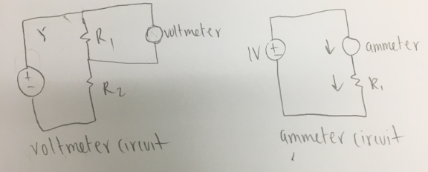  
Figure 1: General Circuits Required For Lab

**Part 3 Discussion And Results:**

**Part A: Computation of Voltage Output and Current**

Using the voltmeter circuit shown in the image above, we solved for the voltage drop. We used the resistance values R1 = 764 kOhms and R2 = 759 kOhms. These values are large because we were advised that large resistances make the value of internal resistance more significant since they will be less than the voltage value. We then applied voltage division to R1 and with this computation we determined the predicted values the voltmeter would show (Figure 1).

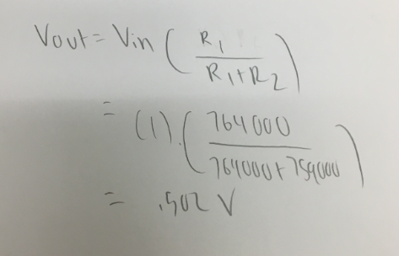

To find the current, we utilized a smaller resistance value, R = 10.23 Ohms. The following shows the result of the current value by using Ohm’s law.

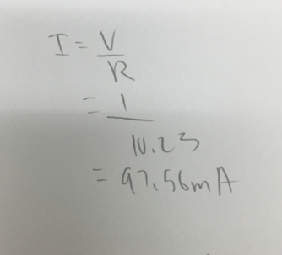

**Part B: Computation of Internal Resistance of the Voltmeter Voltage:**

For this portion of the lab we measured the voltage value of the voltmeter and comparing this value to the expected voltage value. We observed that there is a significant difference between the expected voltage which was 0.502 V and the measured value.

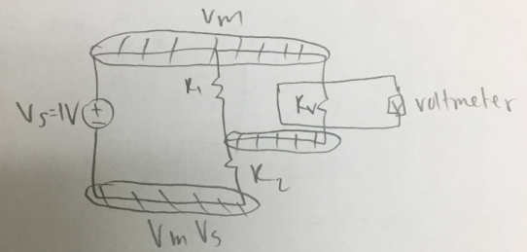

We used the node voltage method to find the internal resistance by using the voltage input and the voltage from the voltmeter. To do this, we used general circuit analysis and picked a ground node to help find the internal resistance. Figure 2 shows how the nodes and ground node is setup relative to the resistances.

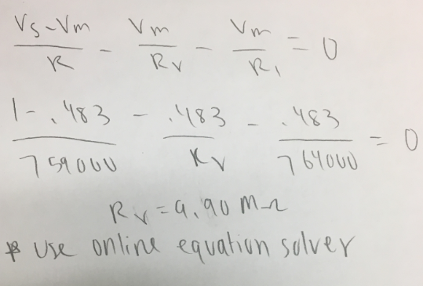

Figure 2: Value of Internal Resistance Relative to Voltmeter

**Part C: Computation of Internal Resistance of Probe 1**

To calculate the internal resistance of the x1 probe, we used the resistor (R2) that is in parallel to the x1 probe. It would be harder to calculate the internal resistance of the other resistor, R1 because it is not directly connected to the x1 probe. We constructed our circuit in a way in which it would be easy to find the internal resistance value by using circuit analysis.

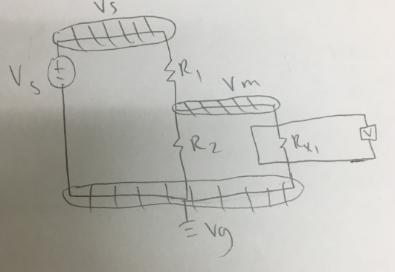

Figure 3: Circuit to Calculate Probe Internal Resistance Values

We plugged in the variables we used in the circuit in the equation seen below, which we derived using node voltage method.

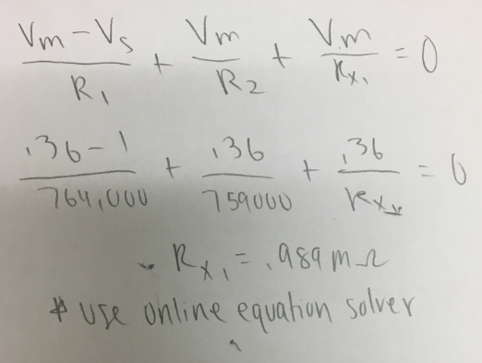

**Part D: Computation of Internal Resistance of X10 Probe**

For this portion of the lab we used the same procedure as we used to compute the internal resistance of X1 probe. We derived the following equation using the node voltage method and referred to the circuit in Figure 3.

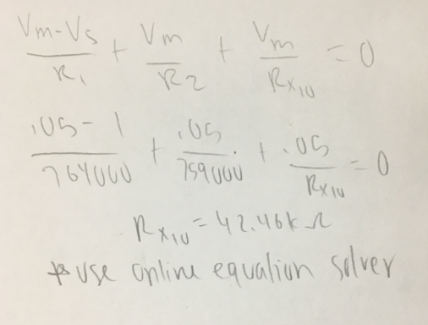

We found the internal resistance of the probe X10 to be 42.46 kOhms.

**Part E: Internal Resistance of the Ammeter**

For this part of the lab we found the internal resistance of the ammeter. We observed that the ammeter circuit was causing the current in the circuit to drop significantly when compared to the value of the actual current. We connected the ammeter to the internal resistor in series and then used KVL to find the value of the internal resistance. Figure 4 below shows the circuit and the calculated internal resistance value.

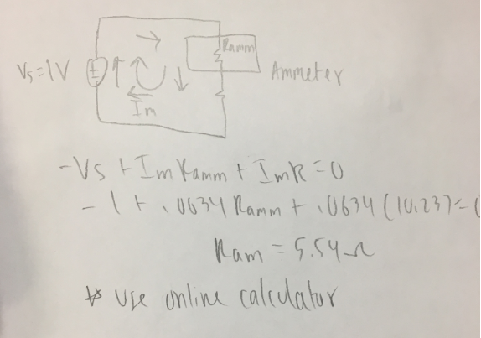

Figure 4: Circuit With Ammeter And Internal Resistance Computation

**A Data Table With The Results:**

|  |  |  |  |
| --- | --- | --- | --- |
| Resistor | Labeled Resistance | Measured Resistance | % Error |
| R1 | 7.6 MΩ | 7.64 MΩ | 2.42% |
| R2 | 7.6 MΩ | 7.59 MΩ | 2.26% |

|  |  |
| --- | --- |
| Voltmeter Measurements: | |
| R1 | 7.64 MΩ |
| R2 | 7.59 MΩ |
| Vm | .483 V |

|  |  |
| --- | --- |
| X1 Oscilloscope Measurements: | |
| R1 | 7.64 MΩ |
| R2 | 7.59 MΩ |
| Vm | 0.36V |

|  |  |
| --- | --- |
| X10 Oscilloscope Measurements: | |
| R1 | 7.64 MΩ |
| R2 | 7.59 MΩ |
| Vm | .05 V |

**Part 4 Conclusion:**

This lab was very important since we were given the opportunity to build simple circuits using different components. It was also a test to see how well we knew how to apply circuit analysis to the circuits we built. We mainly applied the use of KCL and KVL to the circuits we built to find the internal resistances depending upon the different components we used. The main purpose of this lab was to gain practice in computing the internal resistance value which we were able to achieve.

**Part 5 Appendix:**

Some important methods used in this lab are Kirchhoff’s voltage law, voltage division, and resistors in parallel. Resistors in parallel share the same voltage and the equivalent resistance can be found by multiplying the two resistors in the numerator and add the resistors in the denominator. KVL states that the sum of all the voltages in a loop must equal to zero. This law was essential to solving for the internal resistance of the ammeter. Voltage division allows us to calculate for voltage amongst different resistors. Voltage division and the equation for resistors in parallel were crucial to solve the internal resistance of the voltmeter and oscilloscope.

